Which model of probability is most applicable to the following situations?
The probability you will get in a car accident in the next year
- Classical
- Frequency
- Subjective
The probability a nuclear power plant will have an accident this month
- Classical
- Frequency
- Subjective
The probability a roulette wheel will result in “red”
- Classical
- Frequency
- Subjective
What is essential to the classical definition of probability (prob = # ways event can occur / total # of outcomes)
- Outcomes are equally likely
- You have an infinitely long time
- Everyone agrees on the probability
- None of the above
Which of the following is NOT part of the definition of a sample space?
- Set of possible outcomes
- Each outcome must be in S at least once
- Each outcome must be in S at most once
- Each element in S is equally likely
- S can be discrete or continuous
Which of the following is NOT a valid sample space for the experiment: flip a fair coin 3 times
- (0 Heads, 1 Head, 2 Heads, 3 Heads}
- {HHH, HHT, HTH, THH, HTT, THT, TTH, TTT}
- {first flip is H, first flip is T}
- {more H than T, more T than H}
- All are valid sample spaces
Which of the sample spaces DO NOT have equally likely outcomes?
- (0 Heads, 1 Head, 2 Heads, 3 Heads}
- {HHH, HHT, HTH, THH, HTT, THT, TTH, TTT}
- {first flip is H, first flip is T}
- {more H than T, more T than H}
- All have equally likely outcomes
For how many sample spaces can the event “all flips are T” exist? a)0 b) 1 c)2 d)3 e) 4
If the odds in favour of an event are 1:3, what is the probability the event does not occur?
- 1/3
- 2/3
- 1/4
- 3/4
- None of the above
Of the 36 outcomes when 2 6-sided dice are rolled, how many ways are there to have equal values on both dice OR a total of 5?
- 24
- 12
- 10
- 8
- None of the above
Which of the following situations involves sampling without replacement
- Creating a 4-digit PIN (each digit 0-9)
- 6 people getting off a bus at 4 possible stops
- 5 people enrolling in 5 sections of a course
- Writing a 3-letter `word`(each letter A-Z)
- None of the above
Which experiment above has the most elements in the sample space?
- Creating a 4-digit PIN (each digit 0-9)
- 6 people getting off a bus at 4 possible stops
- 5 people enrolling in 5 sections of a course
- Writing a 3-letter `word`(each letter A-Z)
- Two or more are tied
Which of the following situations would be considered a permutation (order matters)?
- Draw a hand of 5 cards from a deck
- Select a committee of 3 people from a class
- 3 people getting matched with 3 co-op employers
- Choose 4 products to test for defects
- None of the above
Suppose 4 people get on an elevator at the basement floor. There are 6 floors above where they can get off. Find the probability at least two people get off at the same floor.
- 2/6 = 0.333
- 6⁽⁴⁾/6⁴ = 0.278
- 1 – 6⁽⁴⁾/6⁴ = 0.722
- 1 – 4⁽⁴⁾/4⁴ = 0.906
- None of the above

Which of the following statements are true?
- Sampling with replacement gives more possibilities than without replacement
- Permutations are used when you do not care about the order of the items
- n^{(k)} = n!/k!
- $\left(\begin{matrix}\text{n} \\ \text{k}\end{matrix}\right)$*k is the same as n^{(k)}
- Two or more are true, or none are true
The Enigma machine had 5 possible rotors to choose from. 3 rotors were chosen and placed in order in the machine, and each set to one of 26 letters for the starting position. How many possible starting positions are there?
- 26⁵ = 11,881,376
- $\left(\begin{matrix}5 \\ 3\end{matrix}\right)$*26³ = 175,760
- 5⁽³⁾*26³ = 1,054,560
- 26³ = 17,576
- None of the above
Suppose out of 10 insurance policies, 3 have fraudulent claims. If 4 policies are investigated, what is the probability of finding 1 fraudulent claim?

- 3*7*7*7/10⁴ = 0.1029
- $\left(\begin{matrix}3 \\ 1\end{matrix}\right)$ * $\left(\begin{matrix}7 \\ 3\end{matrix}\right)$ / $\left(\begin{matrix}10 \\ 4\end{matrix}\right)$ = 0.30
- 3*7*6*5/10⁽⁴⁾ = 0.125
- $\left(\begin{matrix}7 \\ 3\end{matrix}\right)$ / $\left(\begin{matrix}10 \\ 4\end{matrix}\right)$ = 0.10
- None of the above
The US Powerball lottery has players choose 5 numbers from 69 “regular” numbers and 1 from 26 “powerball” numbers. There are $\left(\begin{matrix}69 \\ 5\end{matrix}\right)\left(\begin{matrix}26 \\ 1\end{matrix}\right)$ = 292,201,338 possible tickets. What is the number of tickets that match 4 regular numbers but NOT the powerball number?
- $\left(\begin{matrix}69 \\ 4\end{matrix}\right)$
- $\left(\begin{matrix}5 \\ 4\end{matrix}\right)\left(\begin{matrix}64 \\ 1\end{matrix}\right)$
- $\left(\begin{matrix}5 \\ 4\end{matrix}\right)\left(\begin{matrix}64 \\ 1\end{matrix}\right)\left(\begin{matrix}26 \\ 25\end{matrix}\right)$
- $\left(\begin{matrix}5 \\ 4\end{matrix}\right)\left(\begin{matrix}64 \\ 1\end{matrix}\right)\left(\begin{matrix}25 \\ 1\end{matrix}\right)$
- None of the above
You select 5 cards from a deck of 52 cards (13 ranks of 4 different suits). What is the probability that you get 3 of one rank and 2 of another rank?
- 13*(4C3)*12*(4C2)/(52C5)
- (13C2)*(4C3)*(4C2)/(52C5)
- (13C2)*4*3*2*4*3/(52C5)
- (4C3)*(4C2)/(52C5)
- None of the above

The letters A, A, A, A, A, A, A, B, B, B are arranged at random in a row. The probability the three Bs occur together (BBB) is
- 3/9 = 0.333
- 6!*3!/9! = 0.012 e) none of the above
- 7/84 = 0.083
- 3!*7/84 = 0.5
Six LoL players (3 Gold, 2 Silver, 1 Bronze) are sitting in a row. What is the probability the players on both ends are the same rank? [GGGSSB -> 6!/3!2!1! = 60 arrangements]
- 2/60
- 12/60 e) none of the above
- 40/60
- 48/60
Seven Pokémon Go players (2 Mystic, 2 Intuition, and 3 Valor) are ranked 1 – 7. What is the probability that the players ranked 1 and 7 are from different teams? [MMIIVVV -> 7!/2!2!3! = 210 arrangements]
- 1/210
- 50/210 e) none of the above
- 100/210
- 160/210
Consider a standard 52-card deck (four suits: clubs, diamonds, hearts, spades and 13 cards in each suit). If the sample space is the list of each individual card, which of the following are true?
- “Red card” is not an event
- “Red card” is an event with 1 element
- “Red card” is an event with 2 elements
- “Red card” is an event with 26 elements
- None of the above

What region is shaded?
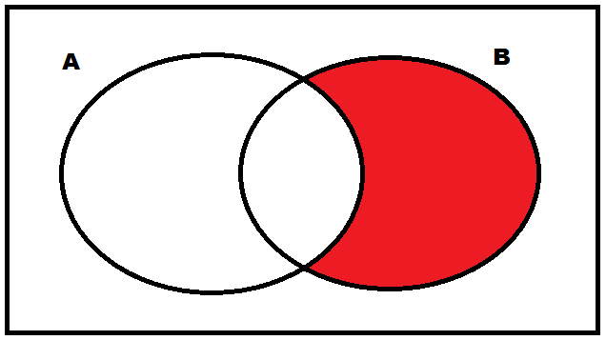
- A^{c} ∩ B
- A^{c} U B
- A^{c} U B^{c}
- A ∩ B^{c}
- None of the above

What picture represents A U B ∩ C?

- 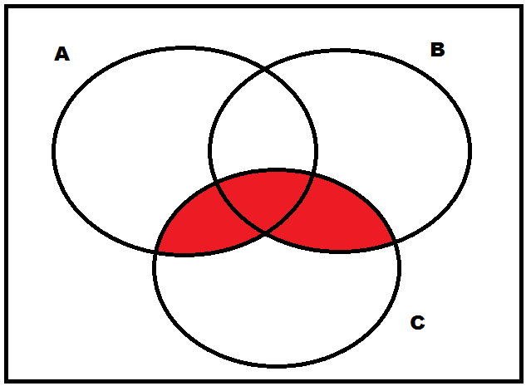
- 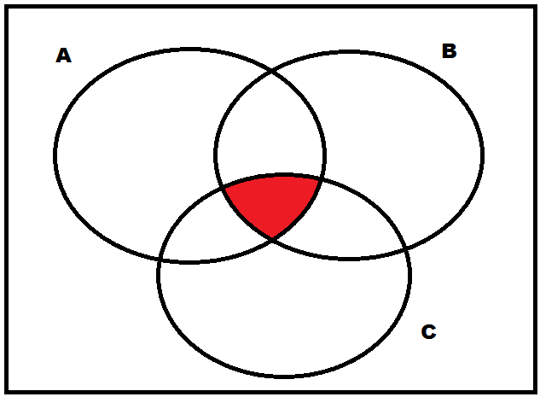
- 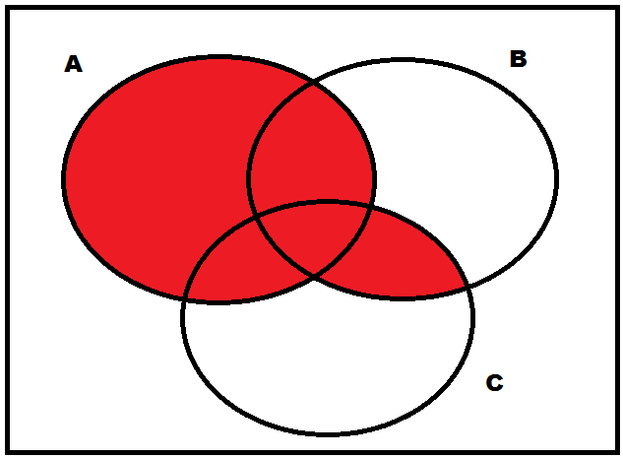
- 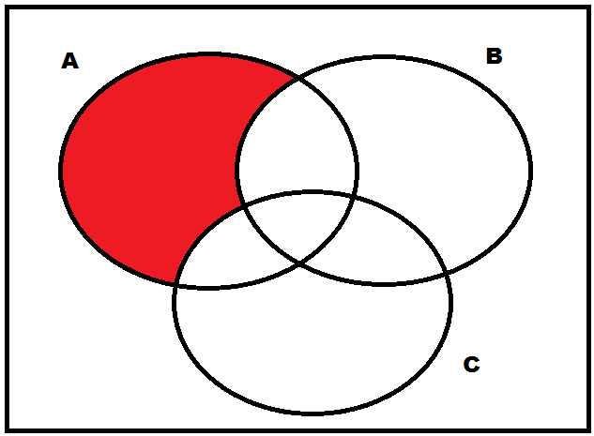

- None of the above
5.4 If two events are such that A is contained in or equal to B, then P(A U B) ≤ P(A) + P(B)
- True
- False
- Not enough information
5.5 If two events A and B are independent and mutually exclusive, then:
- This is impossible
- A must have a probability 1
- Both A and B must have probability 1
- Both A and B must have probability 0
- Either A or B (or both) have probability 0
- None of the above
In a certain term, 500 students enrolled in both STAT230 and MATH237. Of those, 82 got ≥ 80% in STAT, 73 got ≥ 80% in MATH, and 42 got ≥ 80% in both. Which of these probabilities is the smallest?
- Getting ≥ 80% in at least one course
- Getting < 80% in at least one course
- Getting ≥ 80% in both
- Getting ≥ 80% in STAT but not MATH
- Getting ≥ 80% in MATH but not STAT
Roll two fair 12-sided dice. What is the probability that at least one of them is larger than 7?
- 120/144
- 95/144
- 49/144
- 25/144
- None of the above
If A is the event “your computer crashes” and B is the event “there is a power surge” then what is the event “your computer crashes but without a power surge”?
- A U B^{c}
- (A ∩ B)^{c} e) none of the above
- A^{c} ∩ B
- AB

Roll a fair 6-sided die once. Let A = “roll is even” and B = “roll is greater than 3”. Find P(A|B)
- 2/6 = 1/3 b) 1/2 c) 3/4
- 2/3 e)None of the above
Now let C = “roll is greater than 2”. Find P(A|C)
- 2/6 = 1/3 b)1/2 c)3/4
d) 2/3 e)None of the above
Suppose P(A) = 0.5 and P(B) = 0.3, and A and B are independent. Find P( A U B )
- 0.20
- 0.35
- 0.65
- 0.80
- None of the above
When flipping a fair coin twice, let the events:
A = “first flip is H”
B = “second flip is T”
C = “two flips are the same”
D = “both flips are H”
Which pair of events is not independent?

- A and B
- A and C
- A and D
- Two of the above
- None of the above

In the same situation, which pair of events is mutually exclusive?

- A and B
- B and C
- B and D
- Two of the above
- None of the above

Suppose we flip a fair coin 4 times. Let A = “at least 3 Heads”, B = “first flip is tails”. What is P(A|B)?
- 1/16
- 1/8
- 1/4
- 1/5
- None of the above
In the same situation, what is P(B|A)?
- 1/16
- 1/8
- 1/4
- 1/5
- None of the above
Three cards are in a hat. One is blue on both sides, one is red on both sides, and one has one side red and one side blue. A card is drawn at random and you see one side is blue. What is the probability the other side is blue?

- 1/3
- 1/2
- 2/3
- Cannot be determined
- None of the above

Suppose we know P(A|B) > P(A). (That is, if we know B occurs, A is more likely to occur than if we didn’t know anything about B.) Which of the following are not true?
- P(A ∩ B) > P(A)P(B)
- A and B are not independent
- A and B are not mutually exclusive
- P(A^{c}|B) > P(A^{c})
- They are all true
Of the estimated 700 million people who play online games, 1% play World of Warcraft. 3% of non-Warcraft players and 90% of Warcraft players play League of Legends. What proportion of online gamers play LoL?
- 0.90%
- 2.97%
- 3.87%
- 3.90%
- None of the above
If a randomly selected person plays League of Legends, what is the probability they also play Warcraft?
- 90%
- 23.3%
- 76.7%
- 30.3%
- None of the above
Which of the following is false?
- P(ABC) = P(C)P(A|C)P(B|AC)
- P(A|B) = P(AB) /[ P(AB) + P(AB)]
- P(B) = P(B|A) + P(B|A)
- If A and B are independent then P(A|B) = P(A|B)
- Two or more are false, or all are true
Which of the following could not be modelled using a discrete random variable?
- The number of students who pass a class
- How many attempts it takes to beat a game
- The number of votes a candidate receives
- The temperature on a day in October
- How many days until the temp is below 0
For what constant value k is f(x) = kx, for x=1,2,…,10 a valid probability function?

- 1
- 55
- 1/55
- 45
- 1/45

Using the probability function above, what is
P(2.1 ≤ X ≤ 4)?

- 3/55 = 0.0545
- 5/55 = 0.0909
- 7/55 = 0.127
- 9/55 = 0.164
- None of the above

A fair 6-sided die is tossed twice and X=maximum of the two numbers. Find F(3) = P(X ≤ 3)
- 1
- 1/36
- 5/36
- 9/36
- None of the above
Which picture below could be a valid cdf?

- 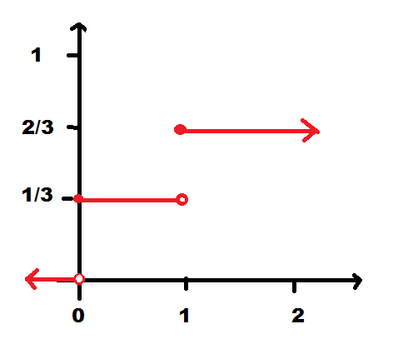
- 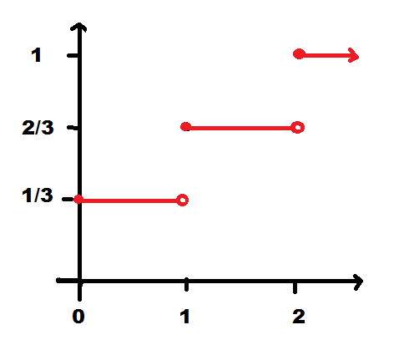

- 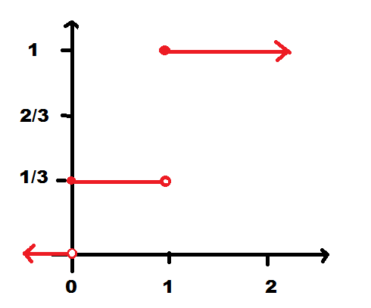
- 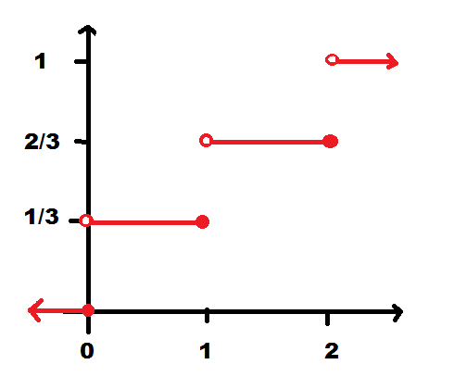

- None of the above

Which histogram of the pf below corresponds to the valid cdf above

- 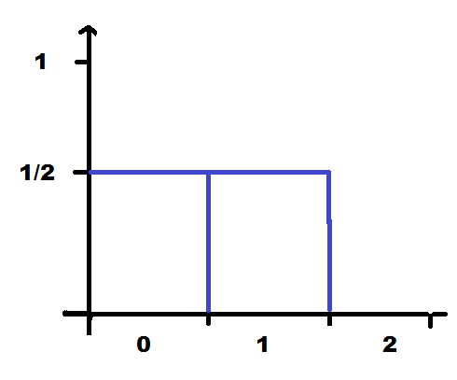
- 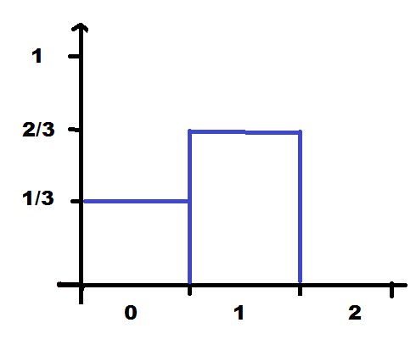
- 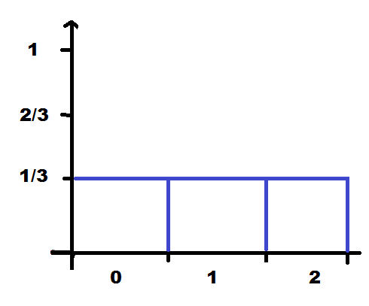
- 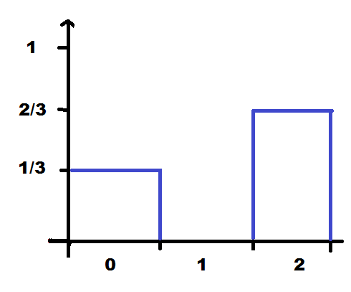

- None of the above

Which of the following are not true?
a) Both f(x) and F(x) are between 0 and 1 (inclusive)
b) F(x) is non-decreasing but f(x) doesn’t have to be
c) If x₀ is smallest value in range of X, then f(x₀)= F(x₀)
d) If x₁ is largest value in the range of X, then F(x₁) = 1
e) They are all true

Which of the following situations could be modelled with a Hypergeometric distribution?
a) The number of Heads in 3 coin flips
b) The number of attempts to pass a course
c) The maximum on 3 6-sided dice
d) Two of the above
e) None of the above

Which of the following situations could be modelled with a Binomial distribution?
a) The number of Heads in 3 coin flips
b) The number of Aces in a hand of 13 cards (from a deck of 52 cards)
c) The number of emails you receive during this class
d) Two of the above
e) None of the above
Suppose you take a multiple-choice test with 5 questions, each of which has 5 choices. You answer completely randomly. What is the probability you get ≥ 80%?
a) 0.00672
b) 0.00032
c) 0.0064
d) 0.0016
e) None of the above
100 cars are parked in a parking lot. 10 are parked there illegally. If Parking Services checks 20 random cars, what is the probability they will catch 2 illegally parked?
- $\left(\begin{matrix}20 \\ 2\end{matrix}\right)$(10/100)² (90/100)¹⁸
- $\left(\begin{matrix}10 \\ 2\end{matrix}\right)$ $\left(\begin{matrix}90 \\ 18\end{matrix}\right)$/$\left(\begin{matrix}100 \\ 20\end{matrix}\right)$ e) none of the above
- $\left(\begin{matrix}20 \\ 2\end{matrix}\right)$ (10/100)²
- $\left(\begin{matrix}20 \\ 2\end{matrix}\right)$ $\left(\begin{matrix}100 \\ 18\end{matrix}\right)$/$\left(\begin{matrix}100 \\ 20\end{matrix}\right)$

100 people are riding the ION. 10 got on without a valid ticket. If an inspector checks 20 random people’s tickets, what is the probability they will catch 2 people without tickets?
- $\left(\begin{matrix}20 \\ 2\end{matrix}\right)$(10/100)² (90/100)¹⁸
- $\left(\begin{matrix}10 \\ 2\end{matrix}\right)$ $\left(\begin{matrix}90 \\ 18\end{matrix}\right)$/$\left(\begin{matrix}100 \\ 20\end{matrix}\right)$
- $\left(\begin{matrix}20 \\ 2\end{matrix}\right)$ (10/100)²
- $\left(\begin{matrix}20 \\ 2\end{matrix}\right)$ $\left(\begin{matrix}100 \\ 18\end{matrix}\right)$/$\left(\begin{matrix}100 \\ 20\end{matrix}\right)$
- None of the above

Which of the following statements 4 are not true about Hypergeometric and Binomial rvs?
a) Both are discrete random variables
b) Both are based on counting the number of S’s in n trials
c) With Binomial the trials are independent but with Hypergeometric they are not
d) The range of Binomial is 0 to n but the range of Hypergeometric depends on N, r, and n.
e) More than one is false, or they are all true

Which of the following situation could be modelled using a Negative Binomial (or Geometric) distribution?
a) The number of cards drawn (without replacement) needed to get 4 Aces
b) The number of rolls of two 6-sided dice before getting a pair of 1’s
c) The number of cars passing through an intersection in 1 hour
d) Two of the above
e) None of the above
Given a situation, which distribution is appropriate?
a) Discrete Uniform d) Negative Binomial
b) Hypergeometric (or Geometric)
c) Binomial e) none of the above
Which of the following statements are not true about Binomial and Negative Binomial rvs?
a) Both are discrete random variables
b) Both are based on Bernoulli trials
c) with Binomial we know the number of S's and with Negative Binomial we know the number of trials
d) Both have min 0 but Negative Binomial has no max
e) More than one is false, or they are all true

Given a situation, which distribution is appropriate?
a) Discrete Uniform
b) Hypergeometric
c) Binomial
d) Negative Binomial (or Geometric)
e) None of the above
Bits in a string are independently flipped (i.e. have an error) with probability 0.05. What is the probability it would take 50 bits to observe 5 errors?
a) $\left(\begin{matrix}50 \\ 5\end{matrix}\right)$(0.05)⁵ (0.95)⁴⁵
b) $\left(\begin{matrix}54 \\ 4\end{matrix}\right)$(0.05)⁵ (0.95)⁵⁰
c) $\left(\begin{matrix}49 \\ 45\end{matrix}\right)$ (0.05)⁵ (0.95)⁴⁵
d) $\left(\begin{matrix}49 \\ 4\end{matrix}\right)$ (0.05)⁴ (0.95)⁴⁵
e) None of the above
Suppose you type at exactly 90 words per minute and on each word have a 1% chance of making an error. After 1 minute, what is the probability you have made NO errors?
a) 0.405
b) 0.407
c) 0.593
d) 0.595
e) None of the above
Which of the following would not be appropriate to model with a Poisson process?
a) Cars passing through an intersection
b) Collisions in a nuclear reactor
c) Website outages
d) Lightning strikes during a storm
e) Attempts to beat a game
Suppose trucks arrive at an inspection station with an average arrival rate of 3 per hour. What is the probability that exactly 5 trucks arrive in a 2-hour period?
a) e^{–3}3⁵/5!
b) e^{–3}3^{2.5}/2.5!
c) e^{–5}5⁶/6!
d) e^{–6}6⁵/5!
e) None of the above
Suppose new posts on a forum occur independently at a constant rate of 3 posts per half hour. What is the probability there are no posts in a minute?
a) e^{–3}
b) e^{–1.5}
c) 1 – e^{–0.1}
d) e^{–0.1}
e) None of the above
In the same situation, consider how many non-overlapping minutes you need to wait before a minute containing a new post occurs. What distribution should you use?
a) Bin(1, e^{–0.1})
b) Geo(e^{–0.1})
c) Geo(1 – e^{–0.1})
d) Poi(e^{–0.1})
e) None of the above
In the same situation, what is the probability that exactly 20 non-overlapping minutes in a half-hour period contain no new posts?
a) (30C20) (e^{–0.1})¹⁰ (1 – e^{–0.1})²⁰
b) (30C10) (e^{–0.1})²⁰ (1 – e^{–0.1})¹⁰
c) (29C19) (e^{–0.1})²⁰ (1 – e^{–0.1})¹⁰
d) (30C20) (e^{–0.1})³⁰
e) None of the above
(Anonymous polling is turned on) How many kids are in your family? (including you)

- 1
- 2
- 3
- 4
- 5 or more

How many courses are you taking this term?

- 1 or 2
- 3
- 4
- 5
- 6 or more

What is the median number of courses people are taking?

- 3.5
- 4
- 4.5
- 5
- 5.5

What is the mode?

- 3.5
- 4
- 4.5
- 5
- 5.5

Suppose X has probability function
x | 0 | 1 | 2
f(x) | 0.5 | 0.2 | 0.3
What is E[X]?
- 0.5 b) 0.8 c) 1.6 d)3 e)0
What is E[2^{X}]?
- 0.8 b) 1.6 c) 2.1 d) 2.23 e) none of the above
What is E[0.5 + 5(2^{X})]?
a) 11 b) 10.5 c) 2.6 d) 0.5 e) none of the above

In the roulette example, what is the expected winnings if you bet on “odd” which pays 1:1?
a) 0.500 b) 0. 474 c) 0.947 d) 1.000 e) none
In the cache example, how small would the probability of a cache hit need to be to have the same expected time with or without the cache?
a) 0% b) 3% c) 6% d) 9% e) 12%

Which statement is false?
a) If g(X) ≥ 0, then E[g(X)] ≥ 0
b) If E[X] = 5, then E[3 + 10X] = 53
c) If E[X] = μ, then E[X – μ] = 0
d) If X is an integer-valued rv, then E[X] is an integer
e) more than one is false, or all are true

Suppose a random variable X only takes 2 values: 0 or 1. If P(X=0) = 0.4, what is E[X]?
a) 0 b) 0.4 c) 0.5 d) 0.6 e) 1
What is Var(X)?
a) 0 b) 0.24 c) 0.36 d) 0.6 e) 1

Consider the histograms below of three random variables, all with mean 5:
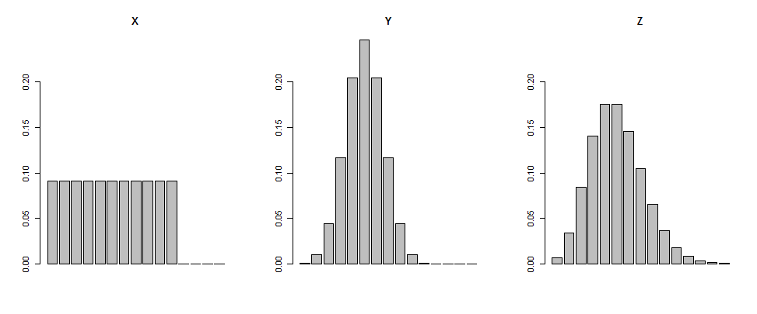
Which do you think has the largest variance?
a) X b) Y c) Z d) two are tied e) can’t tell
Which do you think has the smallest variance?
a) X b) Y c) Z d) two are tied e) can’t tell
Suppose the random variable X has probability function:
x | 0 | 1 | 2 | 3 | 4
f(x) | 0.1 | 0.2 | 0.4 | 0.2 | 0.1
What is Var(X)?
a) 4 b) 1.2 c) 1 d) 2 e) none of the above
Let X = value on one roll of a fair 6-sided die. Find Var(X).
a) 15.167 b) 6.167 c) 2.917 d) 1.708 e) none of above
Suppose the amount of data you use on your phone (in units of 100 MB) has a Poisson distribution with mean 7 per month. You pay $15 per month plus $3 per 100 MB of data. Find the standard deviation of a random month's phone bill.

a) 7.94
b) 8.83
c) 63
d) 47.62
e) none of the above

Let X ~ Bin(10, 0.4). Find the standard deviation of
Y = 3X-2.
a) 2 b) 2.4 c) 4.65 d) 7.2 e) none of the above
Which of the following would NOT be appropriate to model with a continuous random variable?
a) the temperature on a day in November
b) the length of time until a bus arrives
c) the height of a randomly selected person
d) the average height of 10 random people
e) all are reasonable
Suppose a continuous r.v. X on the range (0,1) has cdf F(x) = x² for 0<x<1.
What is its pdf, f(x)?
a) f(x) = x b) f(x) = 2x c) f(x) = x/2 d) f(x) = x³/3 e) none of the above
What is P(X = 0.25)?
a) 0.5 b) 0.25 c) 0.125 d) 0 e) none of the above
What is P(X ≤ 0.25)?
a) 0.875 b) 0.5 c) 0.25 d) 0 e) none of the above
What is E[X]?
a) 1/2 b) 2/3 c) 1 d) 3/2 e) none of the above
What is the median of X?
a) 0.5 b) 0.666 c)0.707 d)1 e) none of the above
A continuous random variable X has pdf f(x) = cx² for 0 < x < 2, and 0 otherwise
Find c.
a) 1/2 b) 2 c) 3/8 d) 8/3 e) none of the above
Find P(X > 1).
a) 1/8 b) 3/8 c) 5/8 d) 7/8 e) none of the above
Find E[X].
a) 3/32 b) 1 c) 3/2 d) 2 e) none of the above
Suppose X has a U(1, 3) distribution. Find the mean and variance.
a) 2 and 1/3 b) 2 and 1/2 c) 2 and 1 d) 1 and 1 e) none

If Y is U(0,1) and X = 2 ³√Y, find f_{X}(x)
a) 3/8 x² for 0<x<2 b) 2 ³√x for 0<x<1
c) 8x³ for 0<x<2 d) x³/8 for 0<x<2 e) none

In a Poisson process with rate λ, let X = time until the second event occurs. Find the cdf of X, F(x) = P(X ≤ x) = P(time to second event ≤ x).

a) 1 – e^{–λx}
b) λxe^{–λx}
c) (1 + λx)e^{–λx}
d) (1 – e^{–λx})²
e) 1 – (1 + λx)e^{–λx}
If the time X until a visitor leaves a website is exponential with mean 20 minutes, find P(X < 30| X > 10)
a) ½ e^{–10/20} b) 1 – e^{–10/20} c) e^{–10/20} d) 1 – e^{–20/20} e) e^{–20/20}

Which of the following is best modelled by an exponential distribution?
a) The distance between consecutive weak spots in a length of copper wire
b) The number of days between drawings of the lottery that have winners
c) The number of accidents at a certain intersection in a year
d) the amount of rainfall in a week
e) the average height of 10 people

You can buy new or refurbished (used) electronics. For a specific product, if 50% of new products last over 3 years and 30% of refurbished products last over 3 years, would an exponential distribution be appropriate to model that product's lifetime?
a) Yes b) c) Not enough information to tell

The weight of a newborn baby can be modelled with a Normal distribution with mu = 7.57 and standard deviation sigma = 1.06. How would the graph of the pdf change if sigma was 1.26 instead?
a) narrower, greater maximum value
b) narrower, smaller maximum value
c) wider, greater maximum value
d) wider, smaller maxiumum value
e) Not enough information to tell
If Z ~ N(0,1), find P(Z < -0.63)
a) 0.64058 b) 0.35942 c) 0.73565 d) 0.26435 e) none
If Z ~ N(0,1), find d such that P(|Z| < d) = 0.9
a) 1.2816 b) 1.6449 c) 0.81594 d) 0.82894 e) none
The scores on the MCAT are Normally distributed with mean 25.3 and standard deviation 6.5. A score of 35 is considered very good. What percentile does a 35 correspond to?
a) 87.08th b) 93.19th c) 99.99th d) 100th e) none
Average daily caffeine consumption is 165 mg. Ninety-nine percent of people consume less than 380 mg. Assuming a Normal distribution, what is the standard deviation σ?
a) 130.7 b) 107.5 c) 167.8 d) 92.4
e) none of the above
Suppose X and Y have the following joint pf:
y x | 1 | 2 | 3
1 | k | 2k | 3k
2 | 2k | 3k | 0
3 | 3k | 0 | 0
Find k
a) 0.01 b) 0.071 c) 0.1 d) 0.053 e) none
Find f_{X}(1)
a) 0.071 = 1/14 b) 0.357 = 5/14 c) 0.429 = 6/14
d) 0.214 = 3/14 e) none of the above
Are X and Y independent?
a) Yes b) No c) Not enough information
Find f(1|Y=2).
a) 0.143 = 1/14 b) 0.357 = 5/14 c) 0.4 d) 0.6 e) none of the above

Find P(X + Y = 4)
a) 1 b) 0.643 = 9/14 c) 0.357 = 5/14 d) 0.214 = 3/14 e) none of the above

If X₁, …, X_{k} ~ Mult(n; p₁, …, p_{k}), are X₁, …, X_{k} indep?
- Yes b) No c) Not enough information

Suppose X= # apple products and Y = # Microsoft products (given at least one of each) have joint pf:
y x | 1 | 2 | 3
1 | 0.30 | 0.17 | 0.20
2 | 0.17 | 0.10 | 0.06
Find P(X + Y = 4)
a) 0.10 b) 0.20 c) 0.30 d) 0.40 e) none
Are X and Y independent?
a) Yes b) No c) Not enough information
Find f(3|Y=1)
a) 0.20 b) 0.769 c) 0.67 d) 0.299 e) none
Four categories are used for a survey question. 40% choose A, 30% choose B, 15% choose C, and 15% choose D, independently. The survey is given to 25 people.
What is the probability that 15 people chose A or B?
a) (25C15) 0.4¹⁵ 0.6¹⁰ b) (25C10) 0.3¹⁰ 0.7¹⁵
c) (25C15) 0.3¹⁵ 0.7¹⁰ d) (25C10) 0.4¹⁰ 0.6¹⁵ e) none
Given that 15 chose A or B, what is the probability that 3 chose D?
a) (25C3) 0.15³ 0.85²² b) (10C3) 0.15³ 0.85⁷
c) (25C3) 0.5³ 0.5²² d) (10C3) 0.5³ 0.5⁷ e) none
For a full-time UW Math Faculty student, let X = number of courses taking and Y = 1 if in co-op, or 0 if in regular. The joint pf is given by (this is real data)
y x | 3 | 4 | 5 | 6
0 | 0.09 | 0.17 | 0.22 | 0.01
1 | 0.05 | 0.10 | 0.32 | 0.04

Are X and Y independent?
a) Yes b) No c) Not enough information
Find f(5|Y=1)
a) 0.22 b) 0.32 c) 0.41 d) 0.59 e) none
Let G = (X+Y)/2 be the number of “courses” reported to the government that a student is taking. Find P(G = 3)
a) 0.09 b) 0.32 c) 0.36 d) 0.59 e) none of the above
Find E[XY].
a) 0.51 b) 2.39 c) 2.295 d) 4.5 e) none of the above
Find Cov(X, Y)
a) 0 b) -1 c) -0.095 d) 0.095 e) none of the above

Suppose X and Y have Poi(5) distributions, and Cov(X,Y) = 2. Find Var(3X - 2Y + 1).
a) 65 b) 25 c) 5 d) 2 e) none of the above

(Anonymous polling is turned on)
Can you roll Do you have Choose
your tongue? brown eyes? answer:
Yes Yes a)
Yes No b)
No Yes c)
No No d)
We found the correlation coefficient between tongue rolling and having brown eyes was . Which statement is most correct?
a) The two factors are strongly positively correlated
b) The two factors are weakly positively correlated
c) The two variables move in opposite directions
d) Having brown eyes causes tongue-rolling ability
e) Being able to roll your tongue causes brown eyes
We found the correlation coefficient between tongue rolling and having brown eyes was – . Which statement is most correct?
a) The two factors are strongly negatively correlated
b) The two factors are weakly negatively correlated
c) The two variables move in the same direction
d) Having brown eyes prevents tongue-rolling ability
e) Being able to roll your tongue prevents brown eyes

Suppose two variables X and Y have non-zero covariance. What can we say?
a) X and Y are independent
b) X and Y are not independent
c) we cannot tell if they are independent
Same question, but for zero covariance.

Suppose each time a sorting algorithm runs, it independently takes a Normally distributed amount of time with mean nln(n) and variance n, where n is the number of items in the list to sort. What is distribution of the total time to sort three lists of 10, 100, and 1000 items?
a) N(7783, 1110) b) N(7391, 1110) c) N(7783, 33.3) d) N(7391, 33.3) e) none of the above
What is the probability that all three lists can be sorted in less than 7500 time units total?
a) 0.00056 b) 0.99944 c) 0.53983 d) 0.46017
e) none of the above
How many cats would you need to have a 0.95 probability that the average height is within 1 cm of the true average?
a) 3 b) 6 c) 9 d) 12 e) none of the above
Suppose your roll a fair 6-sided die 3 times, and you are interested in the number of faces that did NOT get rolled. Let X_{i} = 1 if the number i did not get rolled, and 0 otherwise, for i = 1, …, 6.
Find E[X_{i}].
a) 0.005 b) 0.167 c) 0.421 d) 0.579 e) none
Find Cov(X_{i}, X_{j}) for i ≠ j.
a) 0 (indep) b) -0.039 c) 0.039 d) 0.296 e) none
Note: you can use these results to show that
E[X] = 3.472 where X = X₁ + … + X₆ is the
Var(X) = 0.305 total number of unrolled faces

In the “terrible email server” example from Friday, if N increases, the variance of the # of correct emails will:
- Increase b) Decrease c) Stay the same

Which of the following is NOT a condition for the CLT to apply?
- Variables are independent
- Variables have the same mean μ < ∞
- Variables have the same variance σ² < ∞
- Variables must be continuous
- All are conditions, or more than one is not
Which of the following is the WORST approximation using the CLT?
a) The sum on 40 fair 6-sided dice
b) The total time until 5 events occur in a Poisson process with rate λ = 10 per hour
c) The number of votes for Candidate A in a sample of 300 voters, where the probability of voting for A is 0.4
d) The number of Heads in 50 flips of a fair coin
e) The number of events in 5 hours in a Poisson process with rate λ = 10 per hour
A random variable X is Bin(100, 0.4). What would be the best approximation of P(X ≤ 50)?
a) P(Z ≤ (50 – 40)/24) b) P(Z ≤ (50.5 – 40)/24)
c) P(Z ≤ (50 – 40)/4.9) d) P(Z ≤ (49.5 – 40)/4.9)
e) P(Z ≤ (50.5 – 40)/4.9)
A random variable X has moment generating function M(t) = 0.4 e^{t} + 0.6. Find E[X].
a) 1 b) 0.6 c) 0.6 + 0.4 e d) 0.4 e) can’t be found
Two independent Poisson variables X and Y have mgfs M_{X}(t) = e^{2(e^{t} – 1)} and M_{Y}(t) = e^{3(e^{t} – 1)}, respectively. What is the mgf of X + Y?
a) e^{6(e^{t} – 1)} b) e^{5(e^{t} – 1)}
c) e^{2(e^{t} – 1)}+ e^{3(e^{t} – 1)} d) e^{6(e^{t} – 1)²}
e) cannot be determined
STAT 230 Review Activity
Phase 1
In groups of 7, summarize the main points of your assigned chapter on one piece of paper
(25 minutes)

Phase 2
In 7 new groups (each group consisting of one member from each of the original groups), take turns giving a mini-tutorial using the sheets as they are passed around
(3 minutes each)

STAT 230 Review Activity
Phase 1
In groups of 6, summarize the main points of your assigned chapter on one piece of paper
(25 minutes)

Phase 2
In 6 new groups (each group consisting of one member from each of the original groups), take turns giving a mini-tutorial using the sheets as they are passed around
(4 minutes each)

STAT 230 Review Activity
Phase 1
In groups of 5, summarize the main points of your assigned chapter on one piece of paper
(25 minutes)

Phase 2
In 5 new groups (each group consisting of one member from each of the original groups), take turns giving a mini-tutorial using the sheets as they are passed around
(5 minutes each)

STAT 230 Review Activity
Phase 1
In groups of 4, summarize the main points of your assigned chapter on one piece of paper
(30 minutes)

Phase 2
In 4 new groups (each group consisting of one member from each of the original groups), take turns giving a mini-tutorial using the sheets as they are passed around
(5 minutes each)

