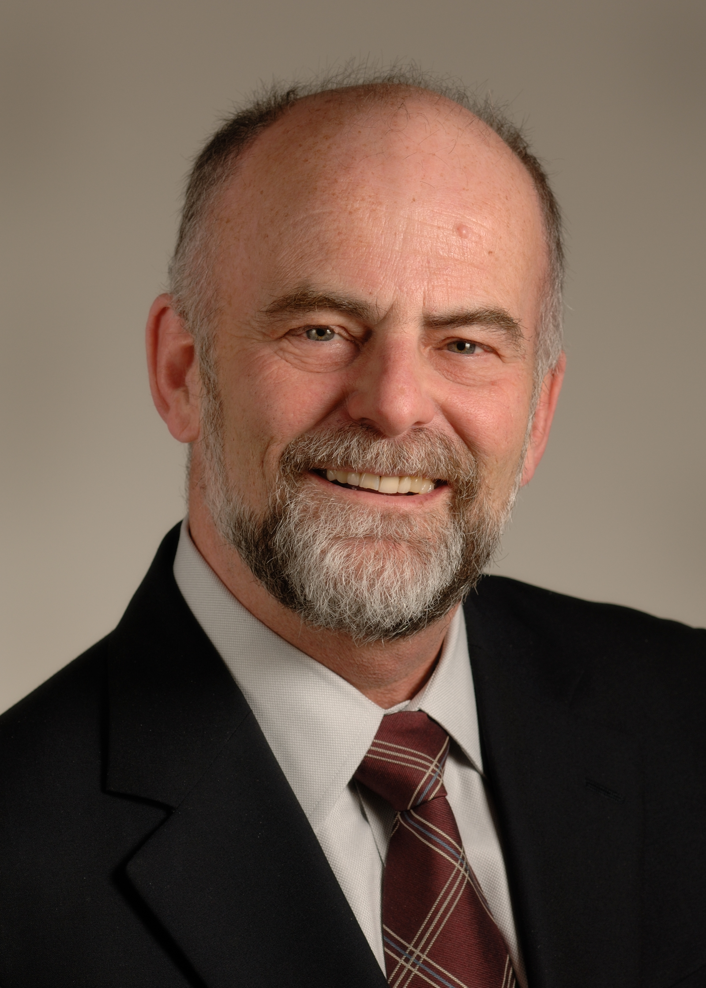 PAUL M. COATES, PH.D.

Dr. Coates retired from U.S. Federal service in 2018 and since that time, he consults with university faculty members who are developing grant applications for submission to the National Institutes of Health (NIH). He has provided guidance at key stages of their academic career development.

He directed the Office of Dietary Supplements (ODS) at the NIH from 1999-2018, in its mission to strengthen knowledge and understanding of dietary supplements. Through a range of initiatives made possible by an energetic and knowledgeable staff, he established ODS as a strong and authoritative voice for rigorous science in dietary supplements and related areas of nutrition. ODS continues to address many of the issues in dietary supplements, from evaluation of the literature to supporting and conducting science, and translating the results of that work into reliable and effective information for the public. His office was instrumental in incorporating evidence-based reviews strategies in the assessment of nutrient efficacy and safety (vitamin D, calcium, sodium, potassium, among others) to inform the development of nutrient referenced intake values for populations.

He was Acting Director of the NIH Office of Disease Prevention (ODP) from 2010-2012. He also served from 1996–1999 as Deputy Director of the Division of Nutrition Research Coordination (DNRC) at the National Institute of Diabetes and Digestive and Kidney Diseases (NIDDK). In that role, He helped to coordinate human nutrition research efforts, both at the NIH and between the NIH and other government agencies. He co-chaired the joint DHHS/USDA Steering Committee for the National Nutrition Summit, held in Washington in 2000. He was a member of the Federal Steering Committee for the development of the U.S./Canada Dietary Reference Intakes. He was Co-Executive Secretary of the Interagency Committee on Human Nutrition Research and Chair of the Federal Working Group on Dietary Supplements.
In 2011, he received the Conrad A. Elvehjem Award from the American Society for Nutrition (ASN) for public service in nutrition. In 2013, he became a Fellow of the ASN and currently serves as Vice President on the ASN Board of Directors. He was lead editor of the Encyclopedia of Dietary Supplements and associate editor of The American Journal of Clinical Nutrition.

Before joining the DNRC, he was NIDDK’s Program Director for the Type 2 Diabetes Research Program (1993–1996) and Project Officer for the multi-center clinical study, Epidemiology of Diabetes Interventions and Complications (1994–1996). From 1994 until his departure from NIDDK, he maintained an active role in career development and fellowship training in the Division of Diabetes, Endocrinology, and Metabolic Diseases.

Prior to his career at NIH, he was on the faculty of the Children's Hospital of Philadelphia and the University of Pennsylvania School of Medicine from 1975-1993. His major research efforts were in inborn errors of lipoprotein metabolism and fatty acid oxidation. He did postdoctoral training in the Department of Human Genetics and Biometry at University College London, after receiving his Ph.D. in human genetics in 1972 from Queen's University in Kingston, Canada. His undergraduate degree was from McGill University (1968) and he is a proud graduate of Outremont High School (1964), both in Montreal.

